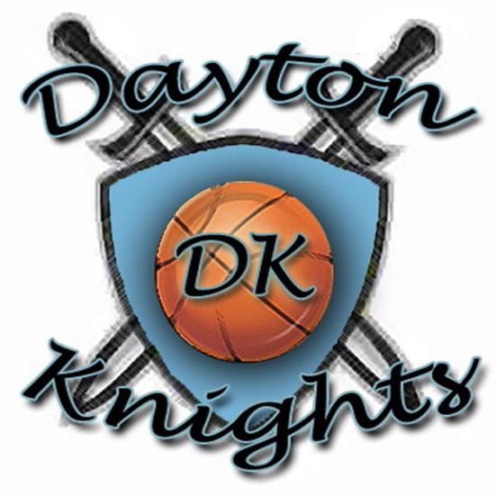
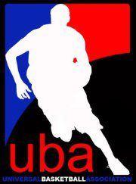
Advertising & Community Partnership
DAYTON KNIGHTS BASKETBALL…A NEW BEGINNING!!!
The Dayton Knights are dedicated to providing a professional basketball franchise with excellence on and off of the court, which will serve the Greater Dayton Area for years to come. While many of the players and coaches may get an opportunity to play and coach professionally overseas or in the NBA, the potential impact that those players may have on the Greater Dayton Area as a whole is tremendous. Our aim is to help enhance the community by continuing to have professional basketball in the city that Dayton can call its own, with team outreaches that will touch the lives of those young and old, while helping players and coaches reach their dreams as well.

We invite you to be our partner in making our vision a reality. Thank you for your consideration.

Team contact Information
Dayton Knights Basketball
Telephone: 937-203-8194
Email: daytonknights@gmail.com

http://daytonknights.wix.com/daytonknights http://www.ubabasket.com/ http://www.usbasket.com/UBA/basketball.asp
Ticket Pricing

General Admission
- Adults - $ 10
- 65 & older - $ 7
- Kids - 12 & under - $ 5
- 3 and under - Free
- Season Ticket passes $ 60 (10 games)
  - 4 Games Free
Group Tickets
- 5-10 10% off
- 11-20 15% off
- 21-30 25% off
- 31+ 50% off

Additional Group Ticket Amenities:
- Have your group's tickets delivered to your group leader
or left for individuals at the door on the night of the game
- Option to reserve an area of the grandstand specifically for your group
- Have your company's logo or message included in the Slam's game day program
- Receive recognition from our public address announcer
- Option to have group members participate in timeout/halftime contest

Sponsorship Investment Opportunities
Dayton Knights 2012-2013 Season

Platinum Co-Presenter Level Sponsors $5000 + (Level 4)

- Title sponsorship for 1 charity/community event
  - Example “Hoopin’ for the Holidays presented by…”
- Logo on Game Jerseys
- Autographed Framed Team Apparel and Basketball
- Discount on Team Apparel (25% off)
- Inclusion of Level 1-3 Sponsorship (Season Pass increase to 20)

Gold Level Sponsors $3500 (Level 3)

- Live Radio Promotion (on-site)
- Logo included on Team Poster
- Logo on pre-game shirts
- Ad announcement during games
- Autograph Basketball & Team Apparel
- Discount on Team Apparel (15% off)
- Inclusion on Game Day Program (full page)
- Inclusion of Level 1 & 2 Sponsorship (Season Pass increase to 15)
Silver Level Sponsors $1500 (Level 2)
- Radio Promotions
- Logo on Game Tickets
- Logo on Game Schedule
- Autograph Basketball
- Game PA Announcements
- Inclusion on Game Day Program (Full Page)
- Discount on Team Apparel (10% off)
- Inclusion of Level 1 Sponsorship (Season Pass increase to 10)

Bronze Level Sponsors $500 (Level 1)
- Logo listed on website sponsor page under “Special Thank You to…”
- Logo on Official Team T-shirt
- Arena Signage
- Logo on Team Printed Ads
- Inclusion on Game Day Program
- 5 Season Pass Ticket Package
- Additional ticket available at discount rate
- Discounts on all available merchandise

2012-13 Event & Community Sponsorship Packages

PLATINUM game sponsorships are an effective and flexible means to promote your business in conjunction with Dayton Knights Basketball. These events are fun and your company will be tied to your choice of event, creating tremendous exposure and impressions. These sponsorships can be combined or customized. These packages are limited.

T-Shirt Sponsors $100

- Name or Logo of business on the back of the official team shirt of the 2012-2013 Season. Plus 2 free tickets for any 2 home games.

YOUTH SPONSOR $5,000
- 50 Tickets to every game will be donated to Youth (Youth Group and/or Organization) on the sponsor’s behalf for the season (20) games. Game day recognition and PA announcements announcing sponsor. Two (2) season passes. Full Page Ad in the program book, and website advertisement.

PLAYER OF THE GAME SPONSOR $50 Per Game or $1,000-season
- Sponsor the MVP player of the game and receive mentions as the “MVP Player of Game” sponsor on radio and game announcement. This sponsorship will cover all home games. Sponsors receive two (2) home game tickets or season passes, full page program ad, PA announcements and website advertisement.

KNIGHTS MEDIA DAY $1,000
- Become a sponsor of the Annual Knights Media Day. This is a great time to be behind the scenes as players get pictures taken and take part in live interviews from the media. This is your opportunity to support this event as well as personally get you and your company’s personal pictures taken with each player and coach of the team. Event tickets, signage, website, advertisement in local media.

KNIGHTS TIME-OUT SPONSOR $1,000 for the season
- Every game timeout will be announced as a sponsorship, at game and live radio. Game day recognition and PA announcements. Two (2) season passes. Ad in the program book, and website advertisement.

HALF TIME 3-POINT SHOT “$100 HOT SHOT” $6,000 for the season
- Sponsor the half-time entertainment 3 point shooter. One fan will be chosen to shoot and win $100 during half time. Sponsor mention during the game and at half-time for entire season. Sponsor receives five (5) season tickets, program ad, PA announcements and website advertisement.

GAME BALL SPONSOR $100 per game or $2,000-season
- At every game 1 ticket holder will be chosen to receive the game ball, and will be announced during and after the game. Players may autograph for winner. Game day recognition and PA announcements. Two (2) home game tickets or season passes. Ad in the program book, and website advertisement.
STARTING LINE UP SPONSOR $100 per game or $2,000-season
- Sponsor the starting lineup and receive game day recognition at the start of every game, for the entire season (home and away games), and on live radio broadcasts. Two (2) home game tickets or season passes, game day recognition via PA announcements, website advertisement.

*****All sponsors will receive
- Newsletter of the team
- International exposure
- Community involvement at local level

